March 5, 2019

**Lab Assignment 2**

Microprocessor & Assembly Language

***Submitted To***

*Mr. Sohaib*

***Submitted By***

*Usama Sarwar*

***FA17-BCS-090***



**COMSATS University Islamabad**

Sahiwal Campus

**Question 1**

|  |  |  |  |
| --- | --- | --- | --- |
| Memory location | Contents | Memory location | Contents |
| 31 | 10h | 34 | 6h |
| 32 | 2Ah | 35 | 11h |
| 33 | 12h | 36 | 9h |

Subtract the contents at memory location 32h & 35h, store and show result in register BX?

**Solution:**

MOV [32], 2Ah

MOV [35], 11h

MOV Cx, [32]

MOV Dx, [35]

SUB Cx, Dx

MOV Bx, Cx

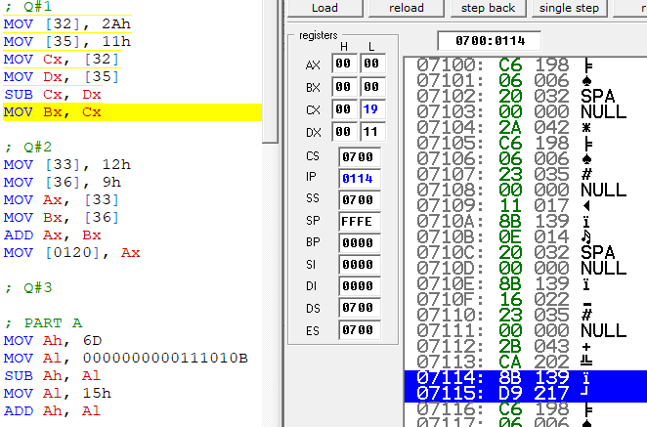

**Question 2:**

Add the contents at memory location 33h & 36h, and show result at memory location 0120h?

**Solution:**

MOV [33], 12h

MOV [36], 9h

MOV Ax, [33]

MOV Bx, [36]

ADD Ax, Bx

MOV [0120], Ax

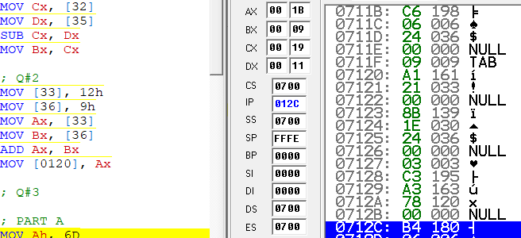

**Yes, value stored in registered.**

**Question 3**

Write codes to evaluate the arithmetic expression “15h+(6d-0000000000111010b)”, by:

* Using one register only
* Using two registers only
* Using three registers

**Solution:**

; PART A

MOV Ah, 6D

MOV Al, 0000000000111010B

SUB Ah, Al

MOV Al, 15h

ADD Ah, Al

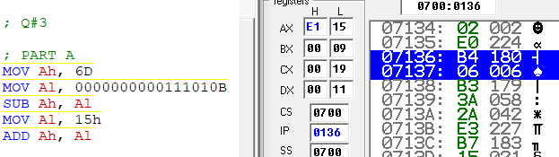

; PART B

MOV Ah, 6D

MOV Bl, 0000000000111010B

SUB Ah, Bl

MOV Bh, 15h

ADD Ah, Bh

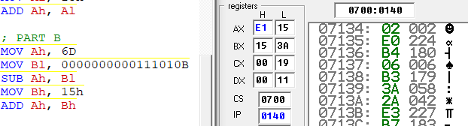

; PART C

MOV Ax, 6D

MOV Bx, 0000000000111010B

SUB Ax, Bx

MOV Cx, 15h

ADD Ax, Cx

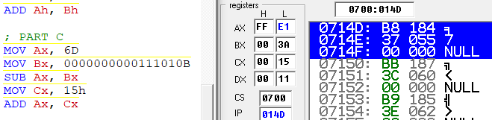

**Question: 4**

If marks of four students are given below:

55,60,62,63

MOV Ax, 55

MOV Bx, 60

MOV Cx, 62

MOV Dx, 63

ADD Ax, Bx

ADD Cx, Dx

ADD Ax, Cx

MOV Bx, 4

DIV Bx

